A COMMUNITY SERVICE PROJECT REPORT ON

“HAND ACTIONS DECODER FOR DEAF AND DUMB USING PYTHON”
Submitted in partial fulfillment of the requirements for the award of the degree
BACHELOR OF TECHNOLOGY
in

ELECTRONICS AND COMMUNICATION ENGINEERING
Submitted by
AMBALLA RAMOJI NADIU | (23021A0403)
BOTHSA ESWARI | (23021A0413)
KANUMULA INDRANI | (23021A0423)
SIRIYALA GEETHA GAYATHRI | (23021A0447)
GUMMALLA SRIVALLIKA (24025A0461)
Under the guidance of
Dr. Avala Mallikarjuna Prasad B.Tech., M.E., Ph.D.
Professor & Director, Admissions


DEPARTMENT OF ELECTRONICS AND COMMUNICATION ENGINEERING

UNIVERSITY COLLEGE OF ENGINEERING KAKINADA (AUTONOMOUS)
Jawaharlal Nehru Technological University, Kakinada Kakinada-533003, Andhra Pradesh, INDIA.
i
UNIVERSITY COLLEGE OF ENGINEERING KAKINADA (AUTONOMUS), JNTU KAKINADA
CERTIFICATE
DEPARTMENT OF ELECTRONICS AND COMMUNICATION ENGINEERING
This is to certify that Community Service Project Report entitled “ HAND ACTIONS DECODER FOR DEAF AND DUMB PEOPLE USING PYTHON ”is being submitted by “CSP BATCH-2” in partial fulfillment for the award of the Degree of Bachelor of Technology in Electronics and Communication Engineering od University College of Engineering Kakinada (Autonomous), JNTU Kakinada, for the record of Bonafide work carried out by them.

NAME OF THE SUPERVISOR: NAME OF THE HOD:

Dr. Avala Mallikarjuna Prasad. B.Tech., M.E., Ph.D. Dr. B. Leela Kumari. M.Tech., Ph.D.
Professor & Director, Admissions Associate Professor & HOD.

PRINCIPAL(SIGNATURE):

ii

COMMUNITY SERVICE PROJECT REPORT
Submitted in accordance with the requirements for the degree of Bachelor of Technology

Name of the College : | University College of Engineering Kakinada
Name of the Department : | Electronics and Communication Engineering
Name of the Faculty Guide : | Dr. Avala Mallikarjuna Prasad. B.Tech., M.E., Ph.D.
Duration of the CSP : | From To
Program of Study : | Bachelor of Technology (B.Tech.)
Class of Study : | II B.Tech.
Names of the Students : | AMBALLA RAMOJI NADIU (23021A0403)
BOTHSA ESWARI (23021A0413)
KANUMULA INDRANI (23021A0423)
SIRIYALA GEETHA GAYATHRI (23021A0447)
GUMMALLA SRIVALLIKA (24025A0461)

Date of Submission :
iii

DECLARATION BY STUDENTS

We the students of B.Tech. Program, with Names and Regd.No’s Amballa Ramoji Nadiu – 23021A0403, Bothsa Eswari – 23021A0413, Kanumula Indrani – 23021A0423, Siriyala Geetha Gayathri – 23021A0447, GUMMALLA SRIVALLIKA (24025A0461) of the Department of Electronics and Communication
Engineering, University College of Engineering Kakinada, do hereby declare that, we have completed the mandatory community service project from to in Kakinada under the Faculty Guidance of Dr. Avala Mallikarjuna Prasad Department of Electronics and Communication Engineering in University College of Engineering Kakinada.

(Student Signature and Date):

AMBALLA RAMOJI NADIU (23021A0403)

BOTHSA ESWARI (23021A0413)

KANUMULA INDRANI (23021A0423)

SIRIYALA GEETHA GAYATHRI (23021A0447)

GUMMALLA SRIVALLIKA (24025A0461)

iv

ACKNOWLEDGEMENT
With the great pleasure and we want to take this opportunity to express our heartfelt gratitude to all the people who helped us in completing this project. We are very grateful to our project Supervisor, Dr. Avala Mallikarjuna Prasad of Department of Electronics and Communication Engineering, for sharing her truthful and illuminating views on different carrier paths available. We also extend my gratitude to our HOD madam, Dr. B. Leela Kumari Madam, further valuable guidance and support in completion of this project. We would like to express our heartful thanks to AICTE for giving us the opportunity to do such a project which enhances the creativity and the analytical thinking of the B.Tech. Students. We would to acknowledge that this project was completed wholly by our team only.

AMBALLA RAMOJI NADIU (23021A0403)
BOTHSA ESWARI (23021A0413)
KANUMULA INDRANI (23021A0423)
SIRIYALA GEETHA GAYATHRI (23021A0447)
GUMMALLA SRIVALLIKA (24025A0461)
vi
CONTENTS

Name of the Chapter | Page Numbers
CHAPTER – 1: ABSTRACT | 01 - 02
CHAPTER – 2: OVERVIEW OF THE  COMMUNITY | 03- 04
CHAPTER – 3: COMMUNITY SERVICE  PART Activity log | 05– 06
CHAPTER – 4: WEEKWISE REPORT  Week – 1  Week – 2  Week – 3 Week – 4  Week – 5 Week – 6 | 07 – 27  07– 09  10 – 14  15 – 18 19 – 21  22 – 23 24 – 27
CHAPTER – 5: TECHNICAL SOLUTION | 28 – 32
CHAPTER – 6: FINAL REPORT AND  CONCLUSION | 33 –34
Team Self Evaluation | 35 – 44
vii

CHAPTER – 1: ABSTRACT

Communication is a fundamental human right, yet individuals with hearing and speech impairments often face significant barriers in expressing themselves and interacting with others. This essay focuses on the development of a Hand Action Decoder for deaf and dumb people using Python, a technology-driven solution aimed at enhancing accessibility, inclusion, and social integration.

Beginning with an overview of communication challenges faced by hearing and speech-impaired individuals, the essay traces the evolution of assistive technologies, from traditional sign language to modern computational approaches. It highlights how advancements in computer vision, machine learning, and artificial intelligence have paved the way for automated hand gesture recognition systems.

The essay delves into the theoretical foundations underpinning the Hand Action Decoder, exploring key concepts such as image processing, feature extraction, and classification algorithms. It emphasizes the role of Python as a versatile programming language that enables the integration of libraries such as OpenCV, MediaPipe, and TensorFlow to build robust gesture recognition models.

Drawing on interdisciplinary perspectives, the essay examines practical applications of the Hand Action Decoder in real-life scenarios. It discusses how real-time hand gesture recognition can translate sign language into spoken words or text, thereby facilitating two-way communication between differently-abled individuals and the hearing population. Applications in education, healthcare, customer service, and public interaction are explored.

Furthermore, the essay addresses the socio-economic impact of this technology, highlighting how it can empower individuals with disabilities by enhancing their independence, employability, and quality of life. Ethical considerations such as privacy, accuracy, and accessibility are also discussed.

Finally, the essay envisions future prospects for the Hand Action Decoder, considering innovations in deep learning, wearable devices, and augmented reality as catalysts for further enhancement. It advocates for inclusive technology design and continued research to ensure that the benefits of digital transformation are accessible to all members of society.

CHAPTER – 2: OVERVIEW OF THE COMMUNITY

Topic: Hand Actions Decoder for Deaf and Dumb People using Python
DESCRIPTION OF THE COMMUNITY:
Kakinada is a coastal city in the East Godavari district of Andhra Pradesh, India. It is known for its seaport, seafood industry, and rapid industrial and educational growth.

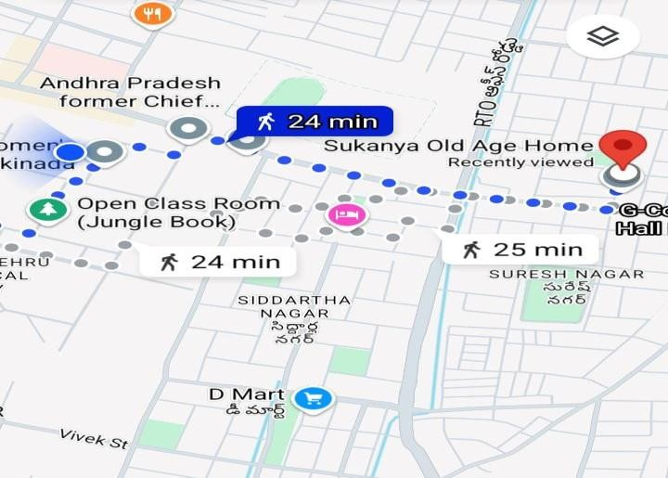

- As part of our Community Service Project (CSP), we visited Sukanya Old Age Home in Kakinada, Andhra Pradesh, which provides care and support to elderly individuals.
- Through interactions with residents and caretakers, we identified key challenges, especially among those with hearing and speech impairments.
- One major issue was the difficulty in communication between elderly residents and caretakers due to these disabilities.
- To address this, we proposed a solution — a Hand Actions Decoder using Python that translates hand gestures into text or speech, aiming to improve communication and reduce social isolation

SUMMARY OF THE ACTIVITIES:
- We visited Sukanya Old Age Home in Kakinada.
- We interacted with the elderly residents, staff, and caretakers to understand their situation.
- A small survey was conducted to identify the problems faced by the elderly.
- The major issue identified was the difficulty in communication for those with hearing and speech impairments.
- To address this, we developed a Hand Actions Decoder using Python that translates hand gestures into spoken words or text, enabling easier communication for the elderly with disabilities.

CHAPTER – 3: ACTIVITY LOG ACTIVITY LOG:

Day & Date | Brief description of the weekly Activity | Learning Outcome | Person In- charge Signature
Week - 1 | We began the project with initial research about the challenges faced by deaf and mute individuals. Our team explored different assistive technologies such as sign language interpreters, wearable devices, and mobile apps. We studied how gesture recognition works and how it could be applied using machine learning. | We understood the major communication barriers and how a vision-based system can help. This helped us shape our idea into a practical and meaningful solution.
Week - 2 | We visited Sukanya Old Age Home in Kakinada to interact with elderly individuals, some of whom had speech and hearing disabilities. We conducted informal surveys to understand how they manage communication in daily life without speech. | We realized that not only young but also elderly people need assistive tools.  It gave us motivation to make our system user-  friendly for all age groups.
Week - 3 | We started technical development. We collected gesture images using a webcam for alphabets (A–Z), numbers (0–9), and simple gestures like | We gained practical skills in using  OpenCV for realtime image capture, preprocessing, and dataset creation. We also understood the importance of
5

 | “Yes”, “No”, “Help”, and  “Thank you”. We used OpenCV for preprocessing and created a labeled dataset with various lighting and hand positions. | data variation and accuracy.
Week - 4 | We built a Convolutional Neural Network (CNN) using TensorFlow/Keras to recognize hand gestures. The model was trained and tested for accuracy. We wrote code to convert the detected gesture into corresponding text output. | We learned how to design, train, and test a deep learning model. This helped us bridge the gap between theory and real-world implementation.
Week - 5 | We integrated the trained model with a Text-to-Speech (TTS) engine using Python libraries like pyttsx3 and gTTS. We also created a simple GUI using Tkinter that shows the camera feed, gesture label, and audio output. | We learned how to build a complete application that combines vision, AI, and user interface. We also tested it with different users and learned how to improve user interaction.
Week - 6 | We presented the prototype to the community and collected their feedback. People appreciated how the system helps those with communication challenges. We also discussed future improvements like adding dynamic gestures | We developed communication and presentation skills.  Community feedback gave us confidence and direction for improving the system further.
6

CHAPTER – 4: WEEK-WISE REPORT
WEEK – 01
INTRODUCTION
- We conducted preliminary research on the communication challenges faced by deaf and mute individuals.
- We visited Sukanya Old Age Home in Kakinada and interacted with caretakers and elderly residents, including those with hearing and speech disabilities.
- We gathered insights on how the lack of proper communication tools negatively impacts their daily activities and relationships with others.
Communication is an essential part of human life. However, people who are deaf and dumb face many difficulties in expressing themselves and understanding others. This challenge creates a gap between them and the rest of society. To overcome this issue, modern technologies such as hand gesture recognition systems are being developed. These systems help translate sign language or hand gestures into text or speech, allowing for better communication.

In this project, we aim to design a Hand Actions Decoder using Python which can help bridge the communication gap. This system uses computer vision and machine learning to recognize different hand signs and display the corresponding message in text or audio form.

Chapter 1: Historical Perspectives

1.1 Origins of Sign Language & Assistive Technology:
- In ancient times, people with hearing and speech disabilities used hand gestures as a basic communication method.
- The first formal sign languages were developed in Europe and later adopted worldwide.
- Advancements in technology like speech-to-text, gesture recognition, and AI have enabled more inclusive communication solutions.
1.2 Development of Gesture Recognition:
- The invention of computers and cameras sparked the idea of digitally recognizing hand movements.
- Advances in AI, Python, OpenCV, and MediaPipe now allow automatic detection of hand gestures.
- These systems are applied in fields like healthcare, education, accessibility, and smart devices.
7

Chapter 2: Principles of Hand Gesture Recognition

2.1 Basics of Hand Gestures and Recognition:

- Understanding Hand Structures: The hand’s fingers, joints, and palm positions form various gestures that are key to decoding.
- Image Capture and Processing: A camera captures live images or videos of hand movements.
- Hand Landmark Detection: Tools like MediaPipe detect key points on the hand to track positions and movements.
- Gesture Classification: Machine learning models or rule-based systems classify gestures into letters, words, or commands.
- Communication Output: Recognized gestures are converted into text or speech using Python libraries to aid communication.
2.2 Technology and Tools Used:

- Python Programming: A simple and powerful language used to build gesture recognition systems.
- OpenCV: An open-source library for image processing and computer vision tasks.
- MediaPipe: A Google library used for real-time hand detection and finger tracking.
- Text-to-Speech (TTS): Converts recognized text into spoken words using Python packages like pyttsx3.
Chapter 3: Practical Implementation of Hand Action Decoding

3.1 Data Collection and Training:
- Collecting Images: Capture images of various hand gestures (e.g., alphabets or sign language words).
- Creating a Dataset: Organize the collected images into categories based on each gesture or word.
- Training a Model: Use machine learning or deep learning to train the system for accurate gesture recognition.
3.2 Building the System:
- Real-time Gesture Detection: Capture live video using a webcam or phone camera.
8

- Hand Tracking: Use MediaPipe to detect the hand and identify key landmarks on fingers and palm.
- Gesture Recognition: Recognize gestures using a trained model or predefined rules.
- Output Display: Show the recognized gesture as text on screen and optionally convert it to speech.
3.3 Real-Life Applications:
- Communication Aid: Assists deaf and mute individuals in expressing themselves in public places, hospitals, schools, and workplaces.
- Accessibility Technology: Develops devices to enhance daily life for people with communication disabilities.
- Further Innovations: Integrates AI and robotics to improve gesture recognition and expand its use in smart devices.
Conclusion:
The Hand Actions Decoder is designed to help deaf and mute individuals communicate effectively using hand gestures. The system utilizes Python, computer vision, and machine learning to recognize hand signs and convert them into text or speech, making communication smoother and more accessible. This project demonstrates how technology can empower people with disabilities and bridge communication gaps. With further development, this system can be implemented in schools, hospitals, and public places, promoting a more inclusive and supportive society. In the future, advancements in AI and smart devices can enhance the system’s capabilities, making it even more accurate, responsive, and user-friend.

WEEK – 2

- As part of our Community Service Project (CSP), we visited Sukanya Old Age Home, Kakinada to interact with elderly people and understand the challenges faced by those with hearing and speech disabilities.
- A survey we conducted revealed that communication is the major issue for individuals who are deaf and dumb.
- To address this, we developed a solution called “Hand Actions Decoder” using Python, which translates hand gestures into text or speech to ease communication.

Hand Actions Decoder Using Python – Practices and Learning

Sukanya Old Age Home is a care facility located in Kakinada that provides a safe and supportive environment for elderly individuals. It is dedicated to offering not just shelter, but also emotional care, medical assistance, and companionship to senior citizens who may be alone or in need of support. The home focuses on ensuring that the residents live with dignity, comfort, and a sense of belonging through regular interactions, activities, and personalized care.
1. Introduction
- The Hand Actions Decoder is a technology-based system developed to help deaf and dumb individuals communicate through hand gestures.
- It is built using Python, integrated with Computer Vision and Artificial Intelligence (AI) tools.
- The primary aim of the system is to reduce the communication gap and enable differently-abled people to express themselves clearly.
2. Gesture Recognition Development:
- We use OpenCV and MediaPipe libraries to capture and detect hand movements in real-time.
- Machine Learning techniques are used to recognize and classify different hand signs.
- The recognized gestures are converted into text or voice output to help others understand what the person wants to say.

10

3. Problem Solving and Application:
- This system is very helpful for people who cannot speak or hear, as it removes the need for others to know sign language.
- It can be used in hospitals, public places, schools, and homes to make daily communication simpler and more effective.
4. Output Display:
- The recognized gesture is displayed as text on the screen or spoken aloud using text-tospeech.
- The system is designed to be accurate and fast in detecting and translating gestures.
- We aimed to make it user-friendly to ensure smooth and easy communication for user
5. Sustainable and Cost-Effective Technology:
- We used free and open-source tools like Python and OpenCV to make the project affordable.
- In the future, we plan to add Artificial Intelligence (AI) and deep learning to make the system smarter and support more gestures and languages.
- We also aim to make the technology accessible to all age groups and easy to use.
6. Conclusion
- The Hand Actions Decoder project is a small but meaningful step toward using technology for social good.
- It helps in creating a more inclusive society where everyone can communicate without barriers.
- We learned the importance of continuous improvement, innovation, and community feedback to make the solution better for real-life use.
This comprehensive overview provides the Hand Actions Decoder is a technology-based system developed using Python, OpenCV, and AI tools to help deaf and dumb individuals communicate through hand gestures. It captures real-time hand movements, recognizes gestures using machine learning, and converts them into text or speech. This system removes the need for others to understand sign language, making communication easier in places like hospitals, schools, and homes. Built with free, open-source tools, it is affordable and user-friendly. In the future, we aim to enhance it with AI and deep learning to support more gestures and languages, making it

accessible for all age groups and promoting a more inclusive society.
Challenges Faced in Developing Hand Actions Decoder for Deaf and Dumb People using Python:

Sukanya Old Age Home serves as a critical support system for elderly individuals by providing shelter, care, and emotional well-being in a safe and compassionate environment. As the aging population continues to grow, such institutions play an increasingly important role in addressing the challenges of elder care, social isolation, and abandonment. However, they face a multitude of obstacles that hinder their effective functioning, including limited financial support, inadequate infrastructure, staff shortages, and the complex emotional and healthcare needs of the residents. This analysis explores these challenges to offer insights into the operational difficulties of old age homes and to guide the development of more sustainable, inclusive, and responsive elder care systems.

- Introduction:
  - Project Purpose: The Hand Actions Decoder uses Python, computer vision, and machine learning to help deaf and dumb individuals communicate by converting hand gestures into text or speech, reducing the need for sign language interpreters.
  - Real-Life Impact: This system enables people with hearing and speech disabilities to express themselves more freely and can be applied in schools, hospitals, and public spaces to promote inclusive communication.
  - Challenges Faced: Key challenges included achieving accurate gesture recognition, handling different lighting and backgrounds, ensuring real-time performance, and creating a userfriendly, efficient system.
- Funding and Resource Challenges:
  - Limited Budget: As a student project, we had very limited funding, which made it difficult to purchase essential components like high-quality cameras, powerful computers, and advanced software tools. This limited our ability to use more sophisticated and efficient technologies.
  - Lack of Resources and Expertise: We faced challenges due to the unavailability of large gesture datasets, access to premium tools for better accuracy, and expert guidance in the fields of AI and machine learning, which affected the overall performance and accuracy of the system.
- Technical Challenges:
    - Accurate Gesture Detection: The system faced difficulties in correctly recognizing hand signs under poor lighting, distracting backgrounds, and during fast or incomplete hand movements, which affected reliability.
    - Limited Dataset: Due to a lack of sufficient sample images of various hand gestures, the model's accuracy and ability to generalize were limited.
    - Real-Time Processing: Ensuring smooth and fast real-time performance without delays or recognition errors was a major challenge, especially on basic hardware.
- Human Resource Challenges:
    - Limited Technical Knowledge: Our team had limited experience in key areas like machine learning (for training the system to recognize gestures) and computer vision (for detecting hand signs using cameras), which made development challenging.
    - Need for Skill Development: We recognized the importance of further learning through workshops, training sessions, or expert guidance to improve our technical skills and enhance the system’s performance.

- Social Acceptance and Practical Use:
    - Technology Familiarity Issues: Some community members may struggle to use the system due to a lack of familiarity with technology, making it less accessible to them.
    - Need for Awareness and Training: We identified the importance of organizing awareness programs and providing simple training sessions to help users feel comfortable and confident while using the system.
- Conclusion:
  - High Impact: The Hand Actions Decoder has the potential to significantly improve communication for deaf and dumb individuals by translating hand gestures into text or speech.
  - Accessibility: It offers a user-friendly, non-invasive solution that doesn't require wearables or interpreters, making it practical for everyday use.
  - Technical Challenges: The system currently faces issues such as low gesture recognition accuracy, slow processing speed, and the need for improved machine learning models.
  - Resource Limitations: Development is hindered by limited funding, access to advanced hardware, and technical support.
  - Need for Awareness and Support: Greater public awareness, community engagement, and continued technical enhancements are essential to make the system more reliable, affordable, and widely adopted.
The Hand Actions Decoder holds great promise in helping deaf and dumb individuals communicate more easily by converting hand gestures into text or speech. Despite its potential, the project faces challenges such as limited funding, low recognition accuracy, and the need for faster processing. Additionally, a lack of social awareness and acceptance can slow down its adoption. With increased support, continuous improvements, and wider outreach, the system can become a more effective, affordable, and inclusive tool for real-world use.

WEEK – 3
- We visited Sukanya Old Age Home in Kakinada and interacted with people who have hearing and speech disabilities.
- We observed their struggles in expressing basic needs due to communication barriers.
- This inspired us to improve our Hand Actions Decoder project, aimed at converting hand gestures into text or speech to help them communicate easily.
Hand Actions Decoder – System Development and Research
We learned that there are different types of hand gestures used in communication, each with its own meaning. We studied these gestures and explored the technologies needed to accurately detect and recognize them.
- Types of Hand Gestures:
  - Basic Communication Gestures
    - Includes gestures like Hello, Thank you, Yes, No, and Help.
    - Used to express basic emotions and responses.
    - The system captures these gestures and converts them into text or voice output. b. Common Action Gestures:
    - Includes gestures for daily activities like Eat, Drink, Sit, Stand, and Sleep.
    - Helps users express personal needs without speaking.
    - Improves independence in daily communication.
c. Alphabet and Number Gestures
    - Covers gestures for letters A–Z and numbers 0–9.
    - Helps users spell names, say numbers, or form words.
    - Makes communication more flexible and detailed.
- Gesture Recognition Technologies:
  - Computer Vision Tools:
    - OpenCV: Used to capture live hand images from the camera.
    - MediaPipe: Detects finger positions and hand movements in real-time.
15
b. Machine Learning Models:
      - The system is trained to recognize various hand shapes and gestures.
      - Once a gesture is detected, it is matched with its correct meaning using trained models. c. Output Conversion:
      - The recognized gesture is displayed as text on the screen.
      - A Text-to-Speech (TTS) feature is included to convert the text into spoken words, making communication easier for others around.
- Practical Applications:
  - Useful at homes for better communication with family members.
  - Helpful in hospitals to express medical needs.
  - Can be used in public places like schools, banks, and offices to communicate with strangers.
  - Makes users feel more independent and connected to society.

- Challenges Faced and Solutions Planned:

S.N0 | Challenges | Solutions Planned
1 | Difficulty in recognizing gestures in poor lighting | Use of better cameras and  preprocessing techniques
2 | Slow recognition speed | Optimize the code for real-time processing
3 | Limited dataset for training | Collect more hand sign images and train the model further
4 | Users unfamiliar with technology | Plan to create a simple, easy-touse interface

Conclusion:
In Week 3, we gained practical exposure by interacting with people who genuinely need this technology, which deepened our understanding of its importance. We realized that each hand gesture carries a unique and meaningful message, highlighting the need for precise recognition and interpretation. This experience motivated us to develop a Hand Actions Decoder that is easy to use, accurate, and affordable. Our ultimate goal is to empower deaf and dumb individuals to communicate confidently and live with dignity in a more inclusive society.
DATA COLLECTION AND MODEL TRAINING
we began the technical development of our project by collecting hand gesture data for training the machine learning model. Using a webcam, we captured various hand signs including:
  - Alphabets (A–Z) from Indian Sign Language (ISL) or American Sign Language (ASL)
  - Numbers (0–9)
  - Commonly used gestures like Hello, Yes, No, Help, Stop, and Thank you
To make the dataset realistic and robust, we collected images under varied lighting conditions (bright, dim, and natural light), hand orientations, and background settings.
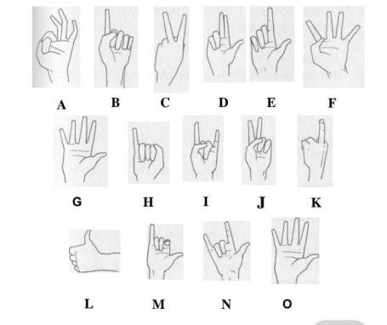

Fig 1 : American Sign Language

Technical Implementation
- Data Preprocessing with OpenCV
  - Converted images to grayscale to reduce complexity.
  - Applied background subtraction to isolate hand regions.
  - Resized images to uniform dimensions (64×64 or 128×128 pixels).
  - Augmented the data using rotation, flipping, and zoom to expand dataset diversity.
- Model Design and Training
  - Designed a Convolutional Neural Network (CNN) using TensorFlow/Keras.
  - The model was trained to recognize patterns and shapes of hand gestures.
  - Dataset split: 80% for training, 20% for testing/validation.
  - Trained over multiple epochs to enhance accuracy.
- Model Evaluation
  - Tested the model on new, unseen images to assess:
    - Accuracy: correctness of predictions
    - Precision: reliability of predictions
    - Speed: system’s real-time responsiveness
  - Initial results were encouraging, but more data and fine-tuning are needed for further improvement.

Key Challenges Faced
- Low performance under poor lighting and fast hand movements.
- Misclassification of visually similar signs (e.g., A vs. S).
- Achieving real-time processing without noticeable lag.

Conclusion
We transitioned from planning to the practical development phase of the Hand Actions Decoder by collecting a diverse set of hand gesture images, preparing a robust dataset, and training our initial Convolutional Neural Network (CNN) model for gesture recognition. Despite challenges such as inconsistent lighting, similar-looking gestures, and the need for real-time responsiveness, these obstacles provided valuable insights into data handling, computer vision, and machine learning. By the end of the week, we had developed a functional gesture recognition model, laying a strong foundation for building a complete communication system and motivating us to further improve its accuracy, speed, and usability in real-world scenarios.

WEEK – 4

SYSTEM DESIGN AND FUNCTIONAL INTEGRATION
Our focus was on integrating all the individual components into a single, cohesive real-time communication system tailored for deaf and mute individuals. We began by implementing a realtime video capture system using a webcam, which continuously feeds input to the gesture recognition module. The machine learning model, trained to identify various hand gestures, was integrated with this live feed to interpret the user’s gestures instantly. To make the output more accessible and meaningful, we linked the recognized gestures to a text-to-speech (TTS) engine that converts the identified signs into spoken words, effectively giving a "voice" to the user's hand gestures.
To ensure user-friendliness, we developed a graphical user interface (GUI) using Python's Tkinter library. The GUI displays the recognized gesture, the corresponding text, and plays the speech output in real time, offering a complete visual and auditory feedback loop. After integration, we conducted multiple rounds of testing and validation to ensure the system worked smoothly and reliably. We tested the system in real-world settings, including at Sukanya Old Age Home, where it was used by elderly individuals with speech and hearing impairments. Feedback collected during testing helped us fine-tune the recognition accuracy, improve GUI responsiveness, and validate the effectiveness of the overall system as a communication aid.
The key areas we worked on include:
- Real-Time Video Capture System
- Gesture Recognition Model Integration
- Text-to-Speech (TTS) System
- GUI Development using Tkinter
- System Testing and Validation
- Real-Time Video Capture (Using OpenCV):
  - Used OpenCV to access webcam and display live video.
  - Added image preprocessing:
      - Grayscale conversion: To reduce noise and improve performance.
      - Background subtraction: To isolate the hand from the background.
      - Image resizing (e.g., 64×64 or 128×128):
  - Improved gesture detection speed and accuracy.
- Integrating the CNN Gesture Recognition Model:
  - Integrated the trained CNN model with live video.
  - Captured hand gestures and predicted corresponding output (e.g., letter/word).
  - Displayed predictions as text in real-time.
Example: Gesture for 'H' displays “H” instantly on screen.
- Text-to-Speech (TTS) Conversion:
  - Implemented both offline (pyttsx3) and online (gTTS) speech synthesis.
  - Spoken output generated from recognized gesture text.
Example: Gesture for “Help” triggers the voice output “Help”.
- Graphical User Interface (GUI) Development (Tkinter):
  - Developed a clean, intuitive interface displaying:
    - Live webcam feed
    - Recognized gesture
    - Text output
    - Voice output option
  - Ensured accessibility for all users.
- Testing the Integrated System:
  - Evaluated the system on:
      - Gesture recognition speed
      - Classification accuracy
      - Clarity of voice output
  - Observations:
      - Accurate with slow gestures
      - Struggles with fast/incomplete signs
      - Needs better performance under low lighting
Challenges Faced and Solutions Applied:
S.NO. | Challenge | Solution
1 | Slow recognition speed | Optimized preprocessing; reduced model complexity
2 | Poor lighting issues | Provided lighting guidelines; improved preprocessing
3 | Confusion in similar gestures | Plan to expand dataset and fine-tune model
4 | No voice output offline | Integrated pyttsx3 for offline speech capability

Conclusion
We successfully integrated all major technical components to develop a functional prototype of the Hand Actions Decoder. This prototype effectively combines real-time hand gesture recognition with text output and speech generation, allowing users with hearing and speech impairments to communicate more easily. The system’s ability to interpret hand signs and convert them into spoken language marks a significant step toward bridging communication gaps and fostering inclusion for differently-abled individuals.
As we move forward, our focus will shift to real-world testing and user interaction. We plan to deploy the system in practical environments—such as old age homes, schools, or care centers—to evaluate its usability and effectiveness. Feedback from actual users will be critical in identifying areas for improvement, such as expanding the gesture vocabulary, improving recognition accuracy, or adding support for regional languages. These insights will guide the next phase of development, ultimately enhancing the system’s performance and making it a reliable tool for everyday communication.

WEEK – 5

COMMUNITY TESTING AND FEEDBACK COLLECTION
We moved beyond development to field testing. With a working prototype in hand, we revisited Sukanya Old Age Home, Kakinada, where we had previously engaged with residents—some of whom had communication disabilities. This real-world environment allowed us to test the system’s usability, gather meaningful feedback, and assess its social impact.
Using a laptop, webcam, and speaker, we set up a demonstration of the Hand Gesture Recognition System and invited users to interact with it.
- Testing Process:
  - Users performed predefined hand gestures (alphabets, numbers, “Hello”, “Thank You”, “Yes”, “No”, “Help”).
  - The system:
      - Captured gestures in real-time,
      - Processed them via the trained CNN model,
      - Displayed text output and generated voice responses.
  - We recorded:
      - Misclassifications,
      - User engagement,
      - Environmental challenges (e.g., lighting, background clutter).
Users performed predefined hand gestures like alphabets, numbers, and phrases such as “Hello” and “Help.” The system captured these in real-time, processed them using a CNN model, and provided text and voice output. We noted misclassifications, user engagement, and issues like poor lighting and background clutter.
- Feedback Collected:
Positive Responses:
    - Users felt empowered seeing their gestures transformed into speech.
    - Caretakers appreciated the non-invasive design—no gloves or sensors required.
    - Educators saw its potential for teaching sign language.
Users responded positively, feeling empowered as their gestures were translated into speech.
Caretakers appreciated the system’s non-invasive design, which required no gloves or sensors.
Educators also recognized its potential as a helpful tool for teaching sign language.
- Identified Challenges:
    - Fast or close gestures caused misclassification.
    - Background clutter interfered with recognition.
    - Elderly users with limited finger flexibility struggled with some gestures.
Fast or closely performed gestures often led to misclassification, while background clutter affected recognition accuracy. Elderly users also faced difficulty due to limited finger flexibility, making some gestures harder to perform.
- Actions Taken:
To address the feedback, we introduced the following improvements:
      - Visual guidance on GUI for ideal hand positioning.
      - Enhanced preprocessing pipeline with brightness correction and noise filtering.
      - Set a confidence threshold to reduce false predictions.
      - Initiated dataset expansion with real-user gesture samples to improve model generalization.
- Technical Enhancements:
    - Auto-adjusted camera settings in OpenCV for better performance in dim lighting.
    - Introduced a delay mechanism to ensure the system captures only stable gestures.
    - Enabled live logging of test sessions for future analysis and training.
Conclusion:
We was a transformational milestone. It validated our system’s potential impact and reminded us that developing assistive technology is not just about functionality—it’s about empathy, accessibility, and continuous improvement. Real-world testing bridged the gap between our code and the community it aims to serve, inspiring us to push further with greater purpose.

WEEK – 6

FINAL PRESENTATION, FEEDBACK & REFINEMENT
- In the final week, we focused on refining the system, completing documentation, and demonstrating it at Sukanya Old Age Home.
- The system converts static hand gestures into text and speech using Python, OpenCV, and Machine Learning, enabling communication for non-verbal users.
- The community trial provided real-life testing, valuable feedback, and insights into the social impact and practical usability of our solution.
We refined the system, completed documentation, and demonstrated it at Sukanya Old Age Home. Using Python, OpenCV, and Machine Learning, the system translates static hand gestures into text and speech, aiding non-verbal communication. The community trial offered real-world testing, helpful feedback, and deeper insight into its social impact and usability.
CHALLENGES FACED DURING FIELD TESTING
- Gesture Recognition Speed:
  - Fast or close gestures led to occasional misclassifications.
  - Users needed time to adapt to the gesture duration and position requirements.
- Lighting & Background Noise:
  - Mixed lighting and background clutter impacted detection accuracy.
  - Darker hand tones were less visible under dim light.
- User Comfort & Familiarity:
  - Some elderly participants struggled with correct hand positioning.
  - Indicated the need for on-screen visual hand guidance and ergonomic UI.
The gesture recognition system faced a few challenges during testing. Fast or closely performed gestures often caused misclassifications, and users needed time to adapt to proper gesture duration and positioning. Detection accuracy was also affected by mixed lighting and background clutter, with darker hand tones being less visible in dim environments. Additionally, some elderly users struggled with accurate hand placement, highlighting the need for visual guidance and a more ergonomic user interface.
FEEDBACK FROM THE COMMUNITY
- Positive Resident Feedback:
  - Users were delighted to hear their gestures spoken aloud.
  - For many, it was their first experience using assistive tech that responded to them personally.
- Suggestions from Elderly Participants:
  - Requested dynamic gesture support for full phrases and emotional expression (common in Indian Sign Language).
- Educators and Staff Insights:
  - System can serve as a sign language learning tool for caregivers and residents alike.
  - Useful for training volunteers and enhancing daily communication.
- Accessibility Proposals:
  - Mobile app version for portability
  - Voice output in local language (Telugu)
  - Simplified GUI tailored for elderly users
Residents responded positively, expressing joy as their gestures were spoken aloud—many experiencing responsive assistive technology for the first time. Elderly participants suggested adding dynamic gesture support for full phrases and emotional expressions, as seen in Indian Sign Language. Educators and staff saw potential in using the system as a learning tool for both caregivers and residents, and for training volunteers. To improve accessibility, they proposed a mobile app version, voice output in Telugu, and a simplified GUI suited for elderly users.

CONCLUSION
Presenting our system at Sukanya Old Age Home was a transformative milestone. The overwhelmingly positive feedback reinforced the relevance and necessity of our work.
We concluded that:
- Community testing ensures the system is truly usable and inclusive.
- Real-time feedback is essential to iterate and refine both UX and model accuracy.
- Empathy-driven design makes technology more impactful and trusted by users.

NEXT STEPS / FUTURE SCOPE
- Dynamic gesture recognition for broader expression
- Mobile version for Android/iOS
- Multilingual support (starting with Telugu)
- Facial expression & emotion recognition
- Larger and diverse dataset for improved training and robustness

Future improvements for the system include adding dynamic gesture recognition to capture a wider range of expressions and emotions. A mobile version for Android and iOS will increase accessibility, while multilingual support, starting with Telugu, will make it more user-friendly. Integrating facial expression and emotion recognition can enhance communication, and expanding the dataset will improve model accuracy and robustness across diverse users.
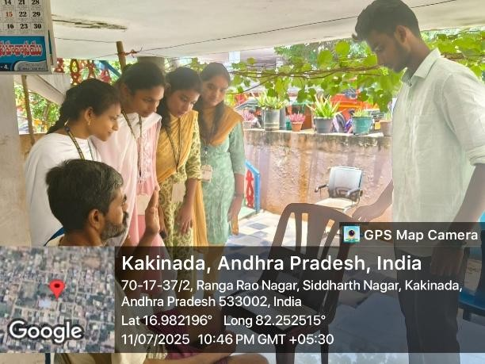
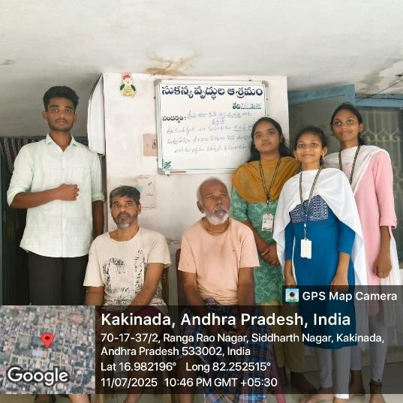

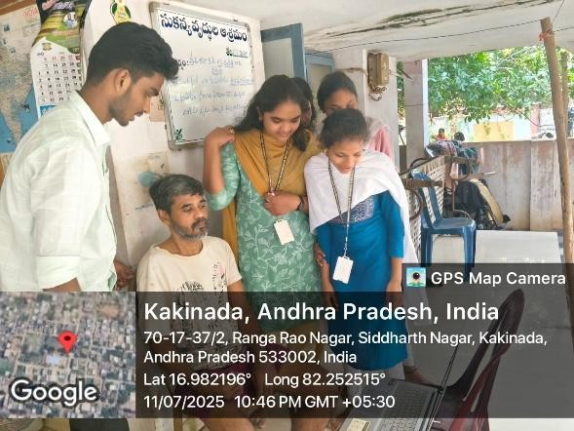

QUESTIONARE

- What is your relationship or experience with individuals who have hearing or speech impairments?
I work as a caregiver at an old age home where a few residents have difficulty hearing or speaking.
- Have you used or seen any assistive technology tools for deaf and mute individuals before? Yes, I’ve seen mobile apps and visual cards being used, but nothing that speaks aloud the signs.
- What communication methods are currently used by individuals with speech and hearing disabilities around you?
They mostly rely on gestures, writing on paper, or help from a caretaker to communicate.
- What challenges do you face while communicating with deaf or mute individuals?
Understanding hand gestures or sign language is difficult unless someone is trained.
- How easy or difficult did you find using the Hand Actions Decoder system?
The system was simple and intuitive. The audio output made understanding immediate.
- Did the system correctly recognize most of the hand gestures you tried?
Yes, it recognized common signs well. A few were missed when gestures were too fast.
- What improvements would you suggest for this gesture recognition system?
Support for moving signs (dynamic gestures), more words, and language options like Telugu.
- Do you think this system could be useful in daily life for individuals with communication disabilities?
Absolutely. It allows them to "speak" without needing help from others.
- Would you consider using this tool regularly if made into a mobile application? Why or why not?
Yes, because it would be more accessible and could be carried anywhere easily.

CHAPTER – 5: TECHNICAL SOLUTION

1. Introduction
In today’s technology-driven world, inclusive communication is essential. Individuals with hearing and speech impairments often face daily challenges in expressing themselves, especially when others are unfamiliar with sign language.
Our project, Hand Actions Decoder, addresses this gap by using computer vision to recognize hand gestures and translate them into text and speech. Built using Python and machine learning, the system requires no wearable devices or interpreters—making it a cost-effective, scalable, and user-friendly solution for real-world use.

2. Need for the Project
During our visits to Sukanya Old Age Home, Kakinada, we observed:
- Difficulty in communication for individuals with speech and hearing impairments.
- Lack of interpreters and limited availability of affordable assistive devices.
- The need for a real-time, infrastructure-light communication solution.
This highlighted the necessity of a system that works with just a webcam and laptop, accessible even in low-resource settings

3. Objective
The core aim of this project is to develop a real-time hand gesture recognition system that:
- Captures hand gestures using a webcam.
- Classifies gestures using a trained machine learning model.
- Converts recognized gestures into readable text and audible speech.
- Provides a simple, accessible GUI for users with minimal technical skills.

4. Components and Technologies Used
Hardware:
- Webcam (built-in or external)
- Laptop/PC

Software & Libraries:
- Python 3.9 – Core programming language
- OpenCV – For real-time video capture and image processing
- TensorFlow/Keras – CNN model training and inference
- NumPy, Pandas – Data handling and processing
- pyttsx3 / gTTS – Text-to-Speech (offline and online options)
- Tkinter / PyQt – GUI design and development

5. System Architecture
Module | Description
Image Capture | Captures live video feed using webcam.
Preprocessing | Converts images to grayscale, filters background, resizes frames for uniformity.
CNN Model | Predicts gesture class based on trained model.
Text Display | Shows recognized gesture on-screen in text format.
Speech Engine | Converts recognized gesture text into audible speech.

6. Flow Chart
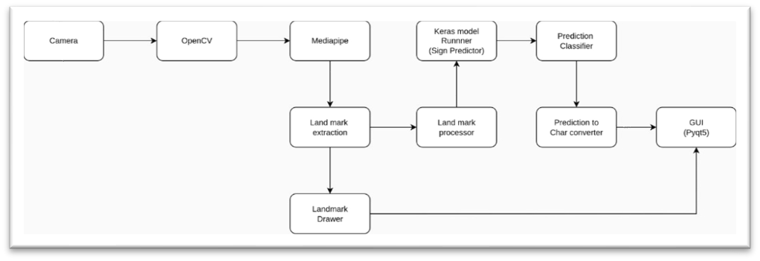

The flowchart shows the working of a hand gesture recognition system. A camera captures realtime video, which is processed using OpenCV and Mediapipe to detect hand landmarks. These landmarks are extracted and processed, then passed to a Keras-based model to predict the corresponding sign. The prediction is classified and converted into a character, which is displayed on a GUI built with PyQt5. Simultaneously, the detected landmarks are drawn and shown on the interface for visual feedback.

7. Working Principle
- The user shows a hand gesture to the webcam.
- The frame is captured and preprocessed using OpenCV.
- The CNN model classifies the gesture.
- The result is displayed as text and spoken aloud.
- This process runs continuously, enabling real-time interaction.

8. Model Training and Dataset
- Dataset: Custom dataset of ~200 images per gesture, covering A–Z, 0–9, and common phrases like Hello, Thank You, etc., under varied lighting conditions.
- Model Architecture:
  - Convolutional Layers
  - MaxPooling Layers
  - Dense Layers • Softmax Output Layer
- Training Results:
  - Training Accuracy: ~95%
  - Validation Accuracy: ~91%

9. Key Applications
- Assistive Communication: Helps individuals express themselves without interpreters.
- Education: Supports teaching and learning of sign language.
- Customer Service: Can be deployed at public counters to aid differently-abled individuals.
- Remote Interaction: Potential for integration into video calling or chat applications.

10. Advantages
- Cost-effective and easy to implement.
- Requires only basic hardware (no sensors or gloves).
- Works offline (via pyttsx3) and online (via gTTS).
- Can be extended for multi-language and gesture training.

11. Challenges Faced
- Difficulty recognizing gestures in low lighting conditions.
- Misclassification of similar-looking gestures (e.g., A vs. S).
- Accuracy affected by rapid or unstable hand movements.
- Dynamic gestures (involving motion) are not yet supported.

12. Community Impact
- Promoted dignity and independence for differently-abled users.
- Reduced reliance on interpreters.
- Inspired local institutions to consider inclusive technology.
- Demonstrated how AI can be used for social good.

13. Future Scope
- Promoted dignity and independence for differently-abled users.
- Reduced reliance on interpreters.
- Inspired local institutions to consider inclusive technology.
- Demonstrated how AI can be used for social good.

Conclusion
This project exemplifies how AI and Machine Learning can be leveraged to create human-centric, socially impactful solutions. By converting hand gestures into speech, the Hand Actions Decoder empowers the deaf and mute community with a digital voice. It paves the way for a more inclusive, compassionate, and accessible society, where technology truly serves humanity.

Output:
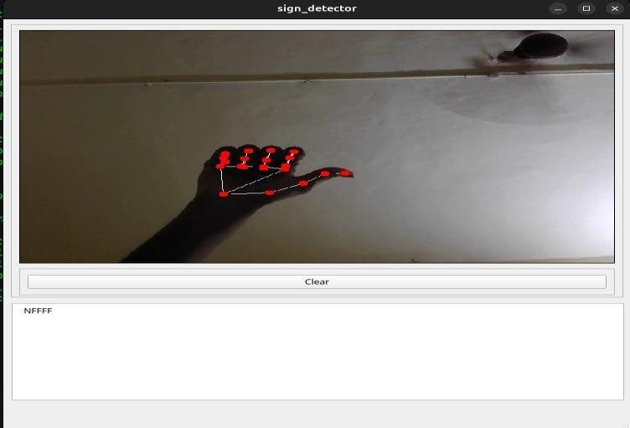

PROJECT LINK : https://github.com/Ramojinaidu/hand_action_decoder

CHAPTER – 6: FINAL REPORT

Report: Community Service Project on Hand Actions Decoder for Deaf and Dumb People using Python
The Hand Actions Decoder project was implemented at Sukanya Old Age Home in Kakinada to support deaf and dumb individuals in expressing themselves through hand gestures. Developed using Python, Computer Vision, and AI tools, the system captures real-time hand movements and converts them into text or speech. This initiative aimed to bridge communication gaps and promote inclusivity by providing a practical, affordable, and userfriendly solution in a real-world setting.
Survey Methodology:
- Real-time prototype was demonstrated at Sukanya Old Age Home using a laptop and webcam.
- Elderly residents and caretakers interacted with the system to test its functionality.
- Feedback was collected on ease of use, gesture recognition accuracy, and overall usefulness.
- Informal interviews with staff provided insights into its potential for daily communication support.
- Observations were made on user behavior, system response time, and environmental factors like lighting and clarity of hand movements.
Survey Results:
- Positive Feedback: Users appreciated the system's usefulness in bridging communication gaps for deaf and dumb individuals.
- Performance & Ease: It recognized gestures well under good conditions, though some elderly users needed help using the system.
- Improvement Suggestions: Requests included adding local language support, emotion recognition, and a mobile-friendly version.
- Community Impact: The demonstration sparked interest and conversations around assistive technology, showing promise for real-world application and inclusivity.

Conclusion:

The Hand Actions Decoder project represents an impactful step towards inclusive communication, especially for individuals with hearing and speech impairments. Through the community testing conducted at Sukanya Old Age Home, several critical insights emerged:
- The system demonstrated real potential in helping non-verbal individuals express themselves using hand gestures.
- Users appreciated the simplicity of the system, though challenges like gesture variation and unfamiliarity with digital devices were noted.
- Despite technical and financial limitations, the prototype proved that affordable and accessible assistive technologies can be developed using open-source tools.
Moving forward, the focus will be on improving gesture recognition accuracy, supporting more languages, enhancing system speed, and creating mobile-compatible versions. Collaborations with technical mentors, healthcare professionals, and community centers will be crucial in making the system more robust and usercentered. Ultimately, the project aims to promote technological inclusivity and ensure that everyone, regardless of ability, can communicate with confidence and dignity.

Rating Scale: Letter grade of CGPA calculation to be provided

Please

rate

your

performance

in

the

following

areas:

Student

Name:

AMBALLA RAMOJI NADIU

Registration No: 2
3
021A040
3

Period of CSP: From

To

Date of Evaluation:

1 Oral communication | 1 | 2 | 3 | 4 | 5
2 Written communication | 1 | 2 | 3 | 4 | 5
3 Proactiveness | 1 | 2 | 3 | 4 | 5
4 Interaction ability with community | 1 | 2 | 3 | 4 | 5
5 Positive Attitude | 1 | 2 | 3 | 4 | 5
6 Self-confidence | 1 | 2 | 3 | 4 | 5
7 Ability to learn | 1 | 2 | 3 | 4 | 5
8 Work Plan and organization | 1 | 2 | 3 | 4 | 5
9 Professionalism | 1 | 2 | 3 | 4 | 5
10 Creativity | 1 | 2 | 3 | 4 | 5
11 Quality of work done | 1 | 2 | 3 | 4 | 5
12 Time Management | 1 | 2 | 3 | 4 | 5
13 Understanding the Community | 1 | 2 | 3 | 4 | 5
14 Achievement of Desired Outcomes | 1 | 2 | 3 | 4 | 5
15 OVERALL PERFORMANCE | 1 | 2 | 3 | 4 | 5

Rating Scale: Letter grade of CGPA calculation to be provided

Please

rate

your

performance

in

the

following

areas:

Student

Name
:

BOTHSA ESWARI

Registration No: 2
3
021A04
13

Period of CSP: From:

To
Date of Evaluation:

1 Oral communication | 1 | 2 | 3 | 4 | 5
2 Written communication | 1 | 2 | 3 | 4 | 5
3 Proactiveness | 1 | 2 | 3 | 4 | 5
4 Interaction ability with community | 1 | 2 | 3 | 4 | 5
5 Positive Attitude | 1 | 2 | 3 | 4 | 5
6 Self-confidence | 1 | 2 | 3 | 4 | 5
7 Ability to learn | 1 | 2 | 3 | 4 | 5
8 Work Plan and organization | 1 | 2 | 3 | 4 | 5
9 Professionalism | 1 | 2 | 3 | 4 | 5
10 Creativity | 1 | 2 | 3 | 4 | 5
11 Quality of work done | 1 | 2 | 3 | 4 | 5
12 Time Management | 1 | 2 | 3 | 4 | 5
13 Understanding the Community | 1 | 2 | 3 | 4 | 5
14 Achievement of Desired Outcomes | 1 | 2 | 3 | 4 | 5
15 OVERALL PERFORMANCE | 1 | 2 | 3 | 4 | 5

Rating Scale: Letter grade of CGPA calculation to be provided




Student

Name:

KANUMULA INDRANI

Registration

No:
2
3
021A04
23

Period

of CSP:

From:

To

Date

of

Evaluation:

Please

rate

your

performance

in

the

following

areas:

1 Oral communication | 1 | 2 | 3 | 4 | 5
2 Written communication | 1 | 2 | 3 | 4 | 5
3 Proactiveness | 1 | 2 | 3 | 4 | 5
4 Interaction ability with community | 1 | 2 | 3 | 4 | 5
5 Positive Attitude | 1 | 2 | 3 | 4 | 5
6 Self-confidence | 1 | 2 | 3 | 4 | 5
7 Ability to learn | 1 | 2 | 3 | 4 | 5
8 Work Plan and organization | 1 | 2 | 3 | 4 | 5
9 Professionalism | 1 | 2 | 3 | 4 | 5
10 Creativity | 1 | 2 | 3 | 4 | 5
11 Quality of work done | 1 | 2 | 3 | 4 | 5
12 Time Management | 1 | 2 | 3 | 4 | 5
13 Understanding the Community | 1 | 2 | 3 | 4 | 5
14 Achievement of Desired Outcomes | 1 | 2 | 3 | 4 | 5
15 OVERALL PERFORMANCE | 1 | 2 | 3 | 4 | 5


Student

Name:

SIRIYALA GEETHA GAYATHRI

Registration

No:
2
3
021A04
4
7

Period

of CSP:

From

To

Date

of

Evaluation:

Please

rate

your

performance

in

the

following

areas:

Rating Scale: Letter grade of CGPA calculation to be provided

1 Oral communication | 1 | 2 | 3 | 4 | 5
2 Written communication | 1 | 2 | 3 | 4 | 5
3 Proactiveness | 1 | 2 | 3 | 4 | 5
4 Interaction ability with community | 1 | 2 | 3 | 4 | 5
5 Positive Attitude | 1 | 2 | 3 | 4 | 5
6 Self-confidence | 1 | 2 | 3 | 4 | 5
7 Ability to learn | 1 | 2 | 3 | 4 | 5
8 Work Plan and organization | 1 | 2 | 3 | 4 | 5
9 Professionalism | 1 | 2 | 3 | 4 | 5
10 Creativity | 1 | 2 | 3 | 4 | 5
11 Quality of work done | 1 | 2 | 3 | 4 | 5
12 Time Management | 1 | 2 | 3 | 4 | 5
13 Understanding the Community | 1 | 2 | 3 | 4 | 5
14 Achievement of Desired Outcomes | 1 | 2 | 3 | 4 | 5
15 OVERALL PERFORMANCE | 1 | 2 | 3 | 4 | 5

Date: Signature of the Student


Student

Name:

GUMMALLA SRIVALLIKA

Registration

No:
24025A0461

Period

of CSP:

From

To

Date

of

Evaluation:

Please

rate

your

performance

in

the

following

areas:

Rating Scale: Letter grade of CGPA calculation to be provided

1 Oral communication | 1 | 2 | 3 | 4 | 5
2 Written communication | 1 | 2 | 3 | 4 | 5
3 Proactiveness | 1 | 2 | 3 | 4 | 5
4 Interaction ability with community | 1 | 2 | 3 | 4 | 5
5 Positive Attitude | 1 | 2 | 3 | 4 | 5
6 Self-confidence | 1 | 2 | 3 | 4 | 5
7 Ability to learn | 1 | 2 | 3 | 4 | 5
8 Work Plan and organization | 1 | 2 | 3 | 4 | 5
9 Professionalism | 1 | 2 | 3 | 4 | 5
10 Creativity | 1 | 2 | 3 | 4 | 5
11 Quality of work done | 1 | 2 | 3 | 4 | 5
12 Time Management | 1 | 2 | 3 | 4 | 5
13 Understanding the Community | 1 | 2 | 3 | 4 | 5
14 Achievement of Desired Outcomes | 1 | 2 | 3 | 4 | 5
15 OVERALL PERFORMANCE | 1 | 2 | 3 | 4 | 5

Date: Signature of the Student

Student

Name:
AMBALLA RAMOJI NADIU

Registration No: 2
3
021A040
3

Period of CSP: From:

To
Date of Evaluation:

Name

of

the

Person

in
-
charge:
Address with mobile number:

Please rate the student’s performance in the following areas:
Please note that your evaluation shall be done independent of the Student’s self- evaluation
Rating Scale: 1 is lowest and 5 is highest rank

1 Oral communication | 1 | 2 | 3 | 4 | 5
2 Written communication | 1 | 2 | 3 | 4 | 5
3 Proactiveness | 1 | 2 | 3 | 4 | 5
4 Interaction ability with community | 1 | 2 | 3 | 4 | 5
5 Positive Attitude | 1 | 2 | 3 | 4 | 5
6 Self-confidence | 1 | 2 | 3 | 4 | 5
7 Ability to learn | 1 | 2 | 3 | 4 | 5
8 Work Plan and organization | 1 | 2 | 3 | 4 | 5
9 Professionalism | 1 | 2 | 3 | 4 | 5
10 Creativity | 1 | 2 | 3 | 4 | 5
11 Quality of work done | 1 | 2 | 3 | 4 | 5
12 Time Management | 1 | 2 | 3 | 4 | 5
13 Understanding the Community | 1 | 2 | 3 | 4 | 5
14 Achievement of Desired Outcomes | 1 | 2 | 3 | 4 | 5
15 OVERALL PERFORMANCE | 1 | 2 | 3 | 4 | 5

Date : Signature of the Supervisor
40

Evaluation by the Person in-charge in the Community / Habitation


Student

Name:

BOTHSA ESWARI

Registration

No:

2
3
021A04
13

Period

of CSP:

From:

To

Date

of

Evaluation:

Name

of

the

Person

in
-
charge:
Address with mobile number:

Please rate the student’s performance in the following areas:
Please note that your evaluation shall be done independent of the Student’s self- evaluation
Rating Scale: 1 is lowest and 5 is highest rank

1 Oral communication | 1 | 2 | 3 | 4 | 5
2 Written communication | 1 | 2 | 3 | 4 | 5
3 Proactiveness | 1 | 2 | 3 | 4 | 5
4 Interaction ability with community | 1 | 2 | 3 | 4 | 5
5 Positive Attitude | 1 | 2 | 3 | 4 | 5
6 Self-confidence | 1 | 2 | 3 | 4 | 5
7 Ability to learn | 1 | 2 | 3 | 4 | 5
8 Work Plan and organization | 1 | 2 | 3 | 4 | 5
9 Professionalism | 1 | 2 | 3 | 4 | 5
10 Creativity | 1 | 2 | 3 | 4 | 5
11 Quality of work done | 1 | 2 | 3 | 4 | 5
12 Time Management | 1 | 2 | 3 | 4 | 5
13 Understanding the Community | 1 | 2 | 3 | 4 | 5
14 Achievement of Desired Outcomes | 1 | 2 | 3 | 4 | 5
15 OVERALL PERFORMANCE | 1 | 2 | 3 | 4 | 5

Date : Signature of the Supervisor
41
Please rate the student’s performance in the following areas:
Please note that your evaluation shall be done independent of the Student’s self- evaluation
Rating Scale: 1 is lowest and 5 is highest rank




Student

Name:

KANUMULA INDRANI

Registration

No:

2
3
021A04
23

Period

of CSP:

From:

To

Date

of

Evaluation:

Name

of

the

Person

in
-
charge:
Address with mobile number:

1 Oral communication | 1 | 2 | 3 | 4 | 5
2 Written communication | 1 | 2 | 3 | 4 | 5
3 Proactiveness | 1 | 2 | 3 | 4 | 5
4 Interaction ability with community | 1 | 2 | 3 | 4 | 5
5 Positive Attitude | 1 | 2 | 3 | 4 | 5
6 Self-confidence | 1 | 2 | 3 | 4 | 5
7 Ability to learn | 1 | 2 | 3 | 4 | 5
8 Work Plan and organization | 1 | 2 | 3 | 4 | 5
9 Professionalism | 1 | 2 | 3 | 4 | 5
10 Creativity | 1 | 2 | 3 | 4 | 5
11 Quality of work done | 1 | 2 | 3 | 4 | 5
12 Time Management | 1 | 2 | 3 | 4 | 5
13 Understanding the Community | 1 | 2 | 3 | 4 | 5
14 Achievement of Desired Outcomes | 1 | 2 | 3 | 4 | 5
15 OVERALL PERFORMANCE | 1 | 2 | 3 | 4 | 5

Date: Signature of the Supervisor
42
Please rate the student’s performance in the following areas:
Please note that your evaluation shall be done independent of the Student’s self- evaluation
Rating Scale: 1 is lowest and 5 is highest rank

Student

Name:

SIRIYALA GEETHA GAYATHRI

Registration No:

2
3
021A04
47

Period of CSP:

From:

To
Date of Evaluation:

Name

of

the

Person

in
-
charge:
Address with mobile number:

1 Oral communication | 1 | 2 | 3 | 4 | 5
2 Written communication | 1 | 2 | 3 | 4 | 5
3 Proactiveness | 1 | 2 | 3 | 4 | 5
4 Interaction ability with community | 1 | 2 | 3 | 4 | 5
5 Positive Attitude | 1 | 2 | 3 | 4 | 5
6 Self-confidence | 1 | 2 | 3 | 4 | 5
7 Ability to learn | 1 | 2 | 3 | 4 | 5
8 Work Plan and organization | 1 | 2 | 3 | 4 | 5
9 Professionalism | 1 | 2 | 3 | 4 | 5
10 Creativity | 1 | 2 | 3 | 4 | 5
11 Quality of work done | 1 | 2 | 3 | 4 | 5
12 Time Management | 1 | 2 | 3 | 4 | 5
13 Understanding the Community | 1 | 2 | 3 | 4 | 5
14 Achievement of Desired Outcomes | 1 | 2 | 3 | 4 | 5
15 OVERALL PERFORMANCE | 1 | 2 | 3 | 4 | 5

Date: Signature of the Supervisor
43
Please rate the student’s performance in the following areas:
Please note that your evaluation shall be done independent of the Student’s self- evaluation
Rating Scale: 1 is lowest and 5 is highest rank

Student

Name:

GUMMALLA SRIVALLIKA

Registration No:

24025A0461

Period of CSP: From:

To
Date of Evaluation:

Name

of

the

Person

in
-
charge:
Address with mobile number:

1 Oral communication | 1 | 2 | 3 | 4 | 5
2 Written communication | 1 | 2 | 3 | 4 | 5
3 Proactiveness | 1 | 2 | 3 | 4 | 5
4 Interaction ability with community | 1 | 2 | 3 | 4 | 5
5 Positive Attitude | 1 | 2 | 3 | 4 | 5
6 Self-confidence | 1 | 2 | 3 | 4 | 5
7 Ability to learn | 1 | 2 | 3 | 4 | 5
8 Work Plan and organization | 1 | 2 | 3 | 4 | 5
9 Professionalism | 1 | 2 | 3 | 4 | 5
10 Creativity | 1 | 2 | 3 | 4 | 5
11 Quality of work done | 1 | 2 | 3 | 4 | 5
12 Time Management | 1 | 2 | 3 | 4 | 5
13 Understanding the Community | 1 | 2 | 3 | 4 | 5
14 Achievement of Desired Outcomes | 1 | 2 | 3 | 4 | 5
15 OVERALL PERFORMANCE | 1 | 2 | 3 | 4 | 5

Date: Signature of the Supervisor
44

